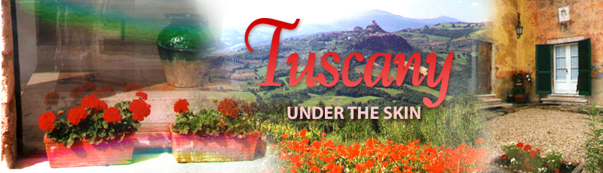

6 nights/7 days - Monday to Sunday

Beat the crowds. Enjoy the romance, traditions and tastes of Undiscovered Italy: Le Marche, bordered by Tuscany, Umbria and the mystic Adriatic Sea. Highlight: A cooking lesson in a local farmhouse to learn how to prepare a typical meal of this region.

DAY 1 – Monday – Macerata & Wine Tasting D
We meet at 13.00 at Foligno railway station and transfer to our charming hotel in the famous old University town of Macerata.
Later this afternoon, drive through beautiful Marchigiana countryside to a wine cellar, once part of a 1400's Hunting Lodge now an elegant Villa. Explore its ancient galleries which provided hiding places and escape routes in former troubled times and now house the Villa's quality wines in their giant wooden vats. Enjoy a tasting of the wines before returning to Macerata for a dinner of specialities from the Le Marche region.

DAY 2 – Tuesday – Farmhouse Cooking Lesson B, L
Put on your aprons at a nearby private farmhouse and learn how to prepare a Harvest lunch using local in-season produce.
Take your time over lunch which will include wines, spirits and liqueurs from yesterday's Villa winery, explore the old farmhouse and learn its history from your hostess.

DAY 3 – Wednesday – Urbino B, D
We take the ocean road above the Adriatic Sea towards the fabled town of Urbino. En route we stop at Loreto and its beautiful church built as a shrine over the childhood home of Mary the Madonna, transported from Nazareth by angels. Or was it the Crusaders? Take time to meditate inside this tiny stone house.
Urbino has been described as " a dream shaped into a city" and has been home to many famous actors, artists and architects. This afternoon we tour the splendid Ducal Palace created in the 1400s by the powerful warlord Federico di Montefeltro, an early man of the Renaissance. Admire the superb rooms and listen for their secrets. Dinner.

DAY 4 – Thursday – Pesaro & Castle of Gradara B
This morning we spend time in the elegant seaside town of Pesaro exploring its old streets and charming courtyard markets. Perhaps visit the home of Rossini, composer of the 'Barber of Seville' and other famous operas or visit the museum which houses an important work by the artist Bellini. The shopping is excellent in Pesaro so enjoy!
We move on to the exquisite castle of Gradara where we learn its tempestuous story and the tragic romance of young Paolo and Francesca.

DAY 5 – Friday – Truffle Hunt B, L
The village of Acqualagna is world famous for its truffles, more expensive than gold. This morning we join the tartufaia and his dogs to go hunting for truffles and afterwards a light lunch tasting of this delicious product. In the afternoon we travel to Fabriano renowned for its handmade paper and the creation of watermarks. We watch the ancient process still done today. Perhaps select the perfect gift for a discerning friend.

DAY 6 – Saturday – Urbania, Ceramics & Farewell dinner B, D
Morning at leisure. Perhaps visit the home of the famous artist Raffaello. Urbino has much to offer. In the afternoon we visit the enchanting village of Fermignano with its ancient water- mill race. This village was home to the architect Bramante who worked on the shrine in Loreto, on St Peters in Rome and other major projects.
We move on to a jewel of a town, Urbania, where for centuries artisans have made fine china and ceramics. Explore the old alleys with their workshops before a delicious farewell dinner. Here the chef creates her menus from herbs gathered in the surrounding fields, from roses, and home-grown products. The perfect farewell to Le Marche.

DAY 7 – Sunday B
Transfer to Arezzo railway station, arriving by 14.00

*************************

